**AWS DAY-4 Assignments included Project-3**

1.Launches linux servers as LINux1 and Linux2

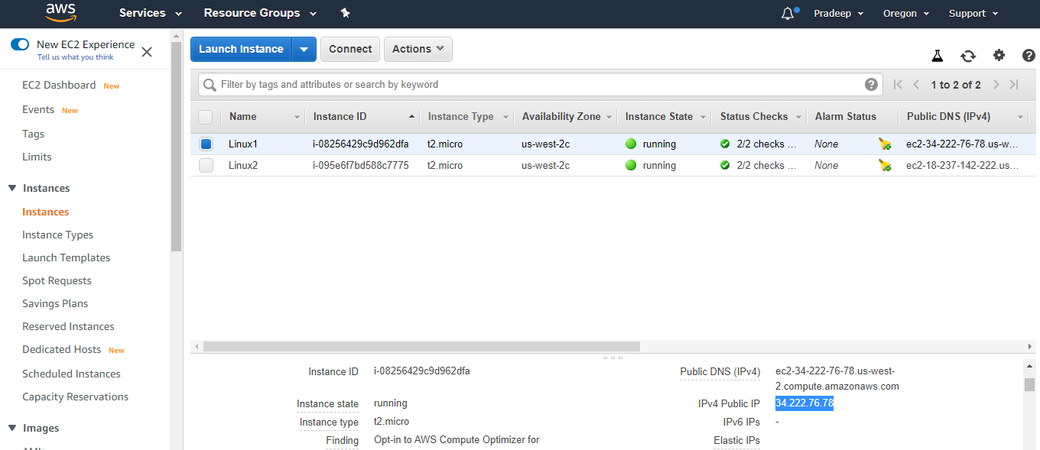

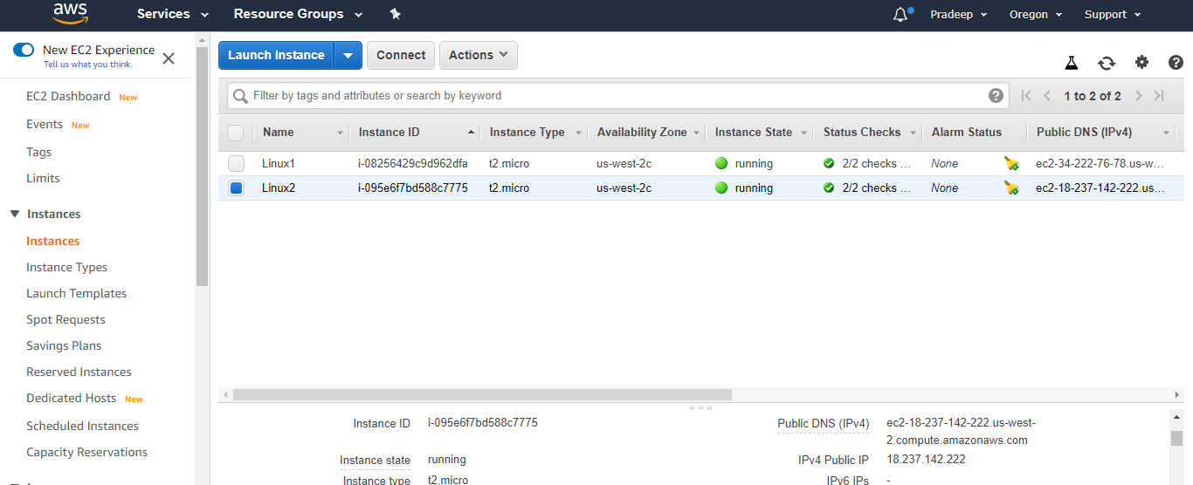

2. Install httpd servers and host applications in both vm

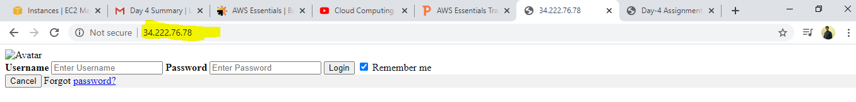

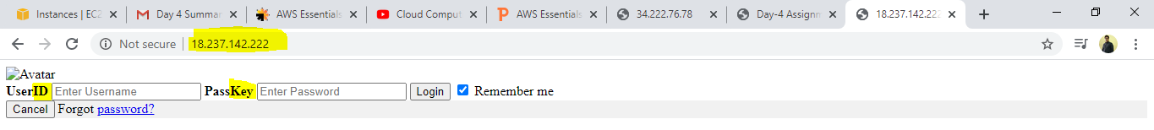

3.Load Balancer created

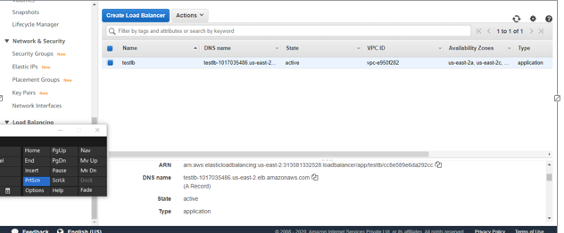

Server -1 login page by load balancer

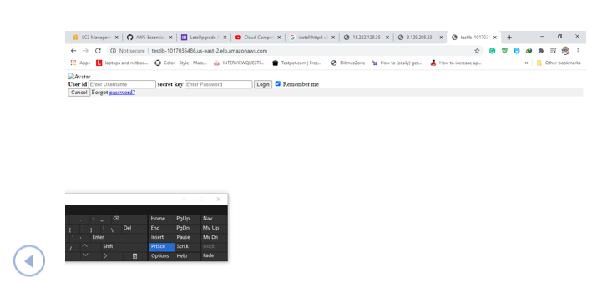

Server -2 login page by load balancer

